Three Step Directions
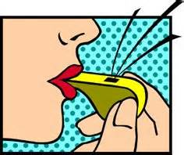
Blowing of Whistle = rolling of arms

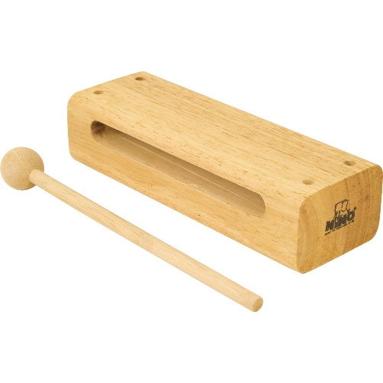
Cluck cluck of wood = Boogie down

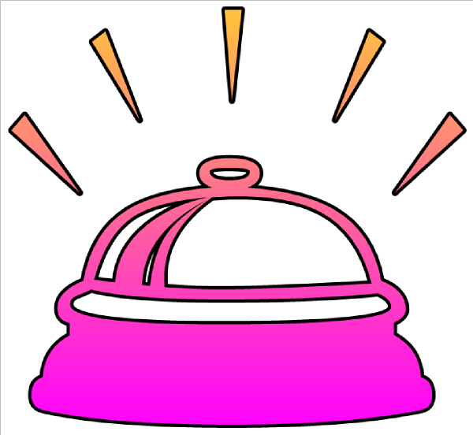
Dinging of a bell = Surprise

