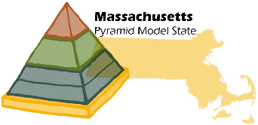

Online Resources

http://connectedbeginnings.org/mapyramidmodel/

http://csefel.vanderbilt.edu/index.html

http://challengingbehavior.fmhi.usf.edu/

http://www.pyramidmodel.org/

